April James

[jamesap@oregonstate.edu](mailto:jamesap@oregonstate.edu)

**Project #5: Spotty the Blob**

The fifth CS450 graphics assignment is all about shaders. The objectives included:

* Experimenting with both vertex and fragment shaders
* Using shaders to dynamically manipulate vertex positions
* Use shaders to draw a dynamic surface pattern
* Incorporate lighting with shaders

The original object is a sphere. In the vertex shader, I manipulated the sphere by enveloping the xyz coordinates along with a value that varied with time in sine/cosine functions. Then, I set an in/out variable, vColor, to change based on st coordinates and passed it along. In the fragment shader, I took care of lighting as well as the dynamic pattern. If the st coordinate was within a certain radius of points I designated which varied with time, that fragment would be discarded. Freezing and playing the animation are controlled with keystrokes. Here are screenshots of my little blob:

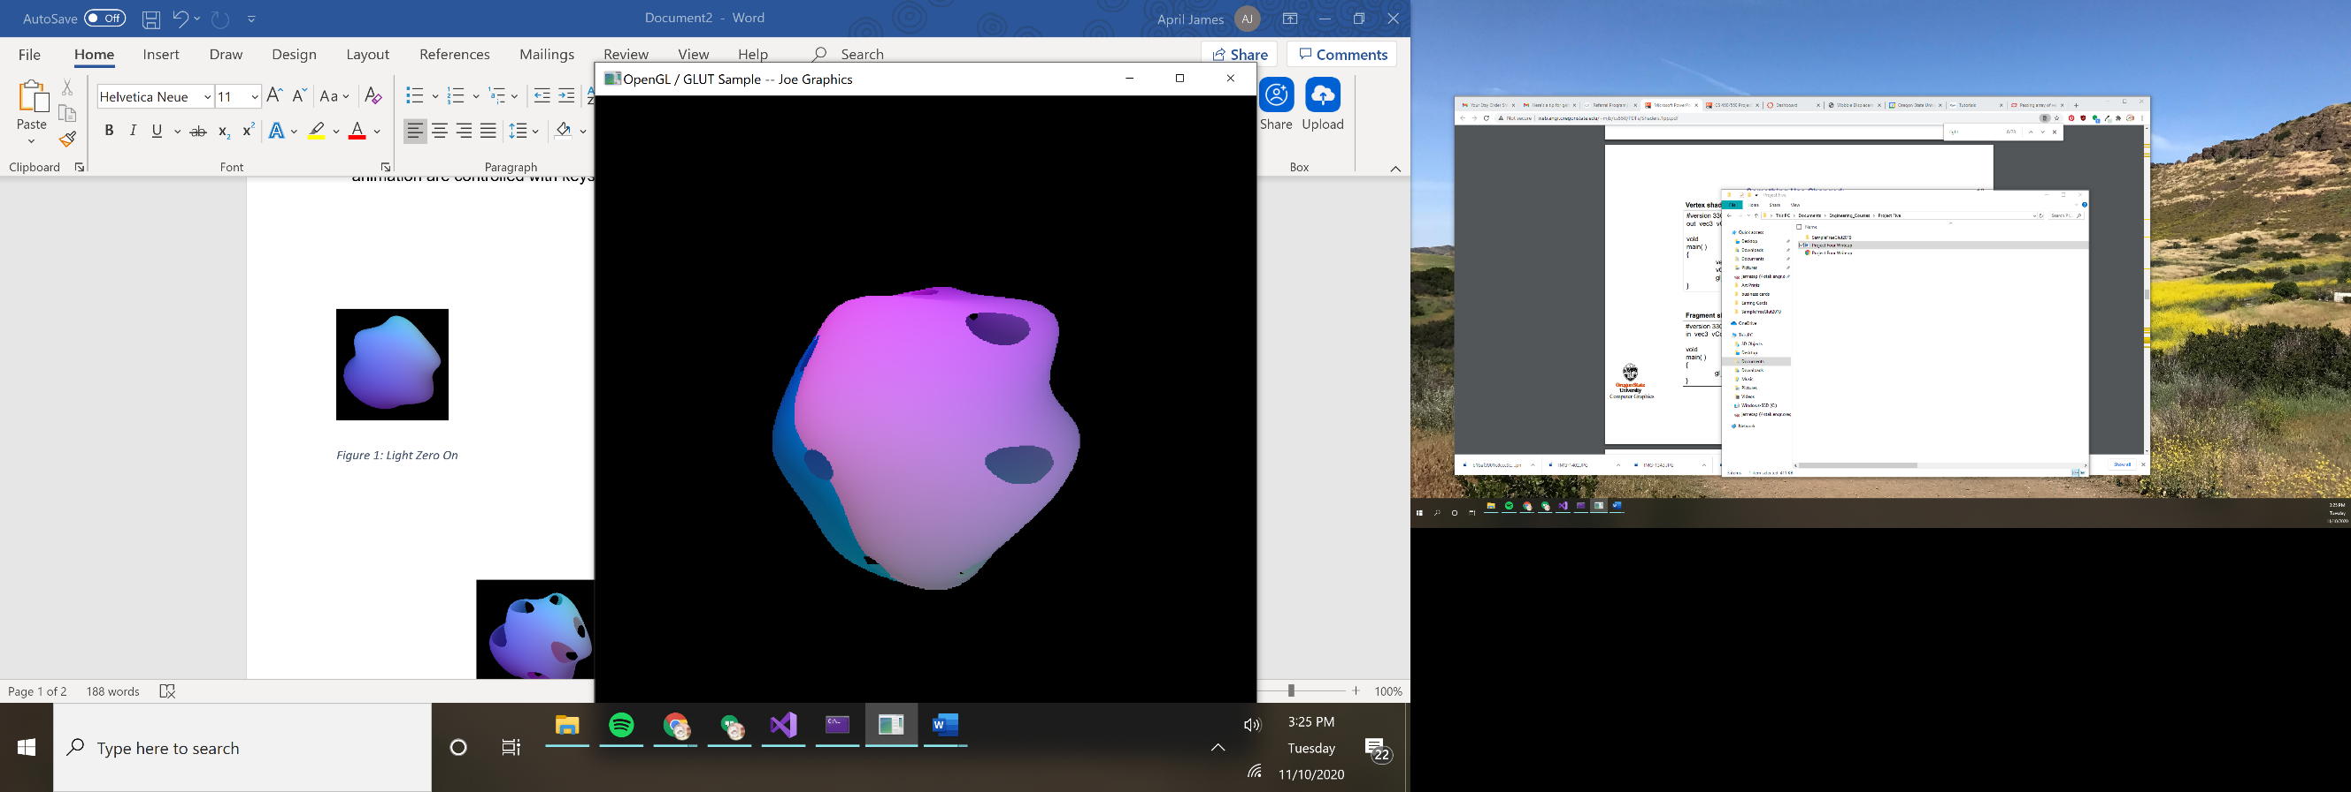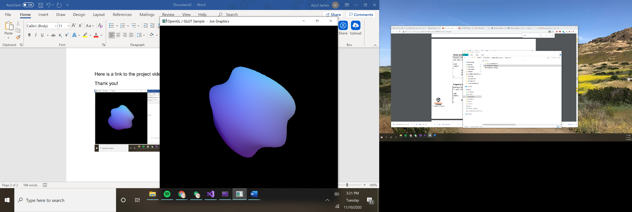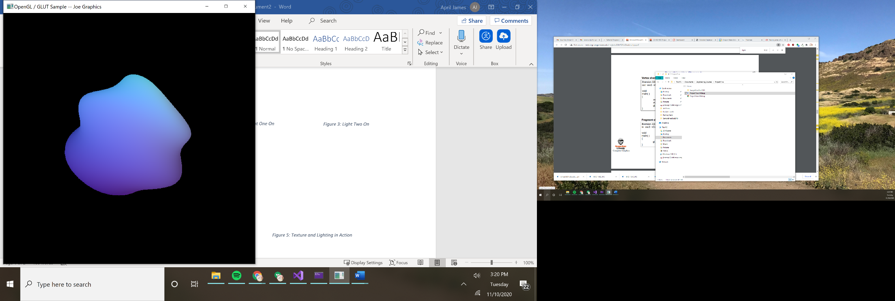

Figure 2: There Goes Vertex Shader!

Figure 1: Completely Frozen

Figure 3: Backside View, Awkward Seam

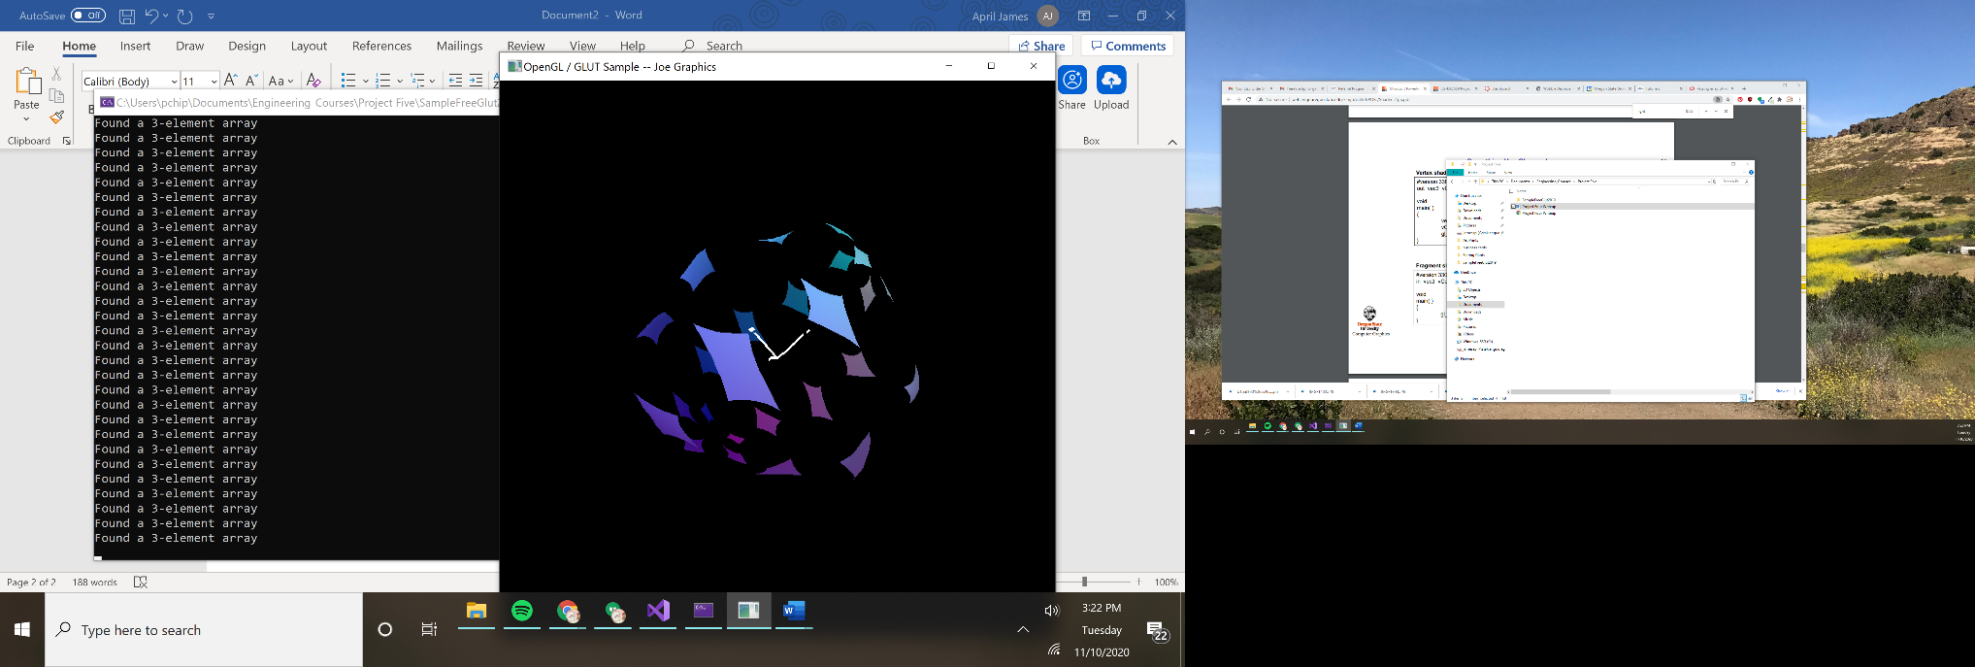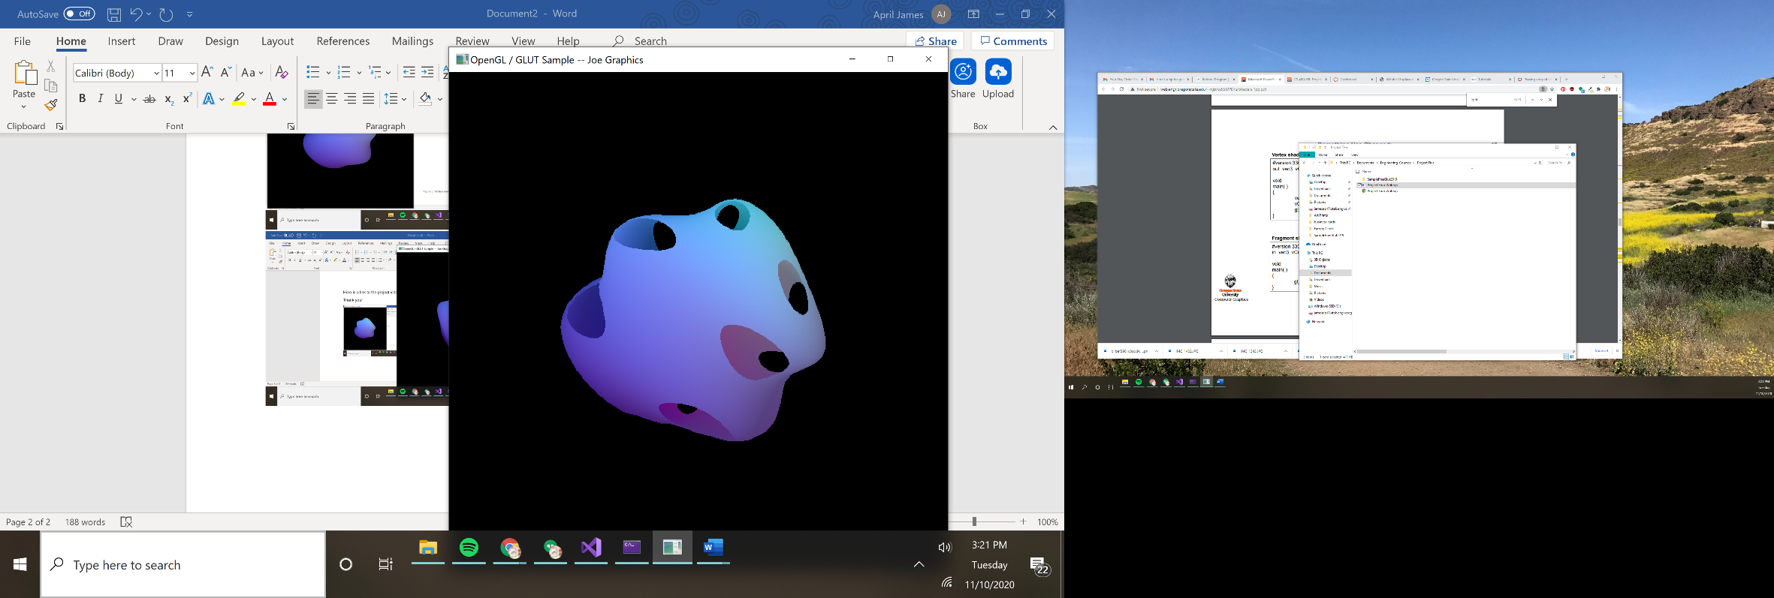

Figure 4: Ooh Look At That Fragment Shader Go!

Figure 5: Fragment Shader Partway Through Animation Cycle

Here is a link to the project video: <https://youtu.be/PVyNQ2KHrjM>

Thank you!